|  |
| --- |
| Node Js |

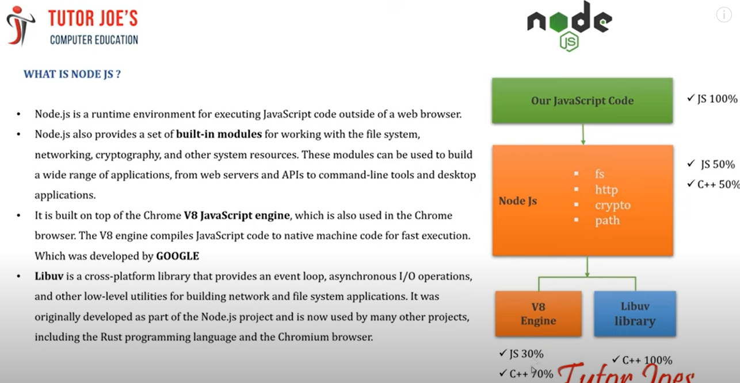

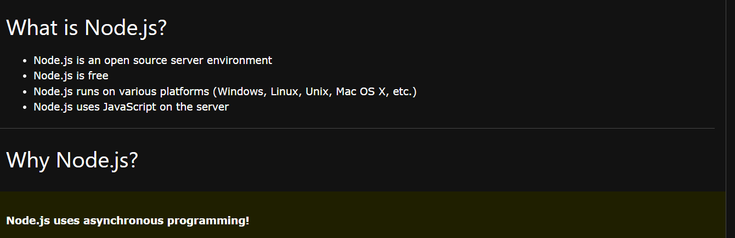

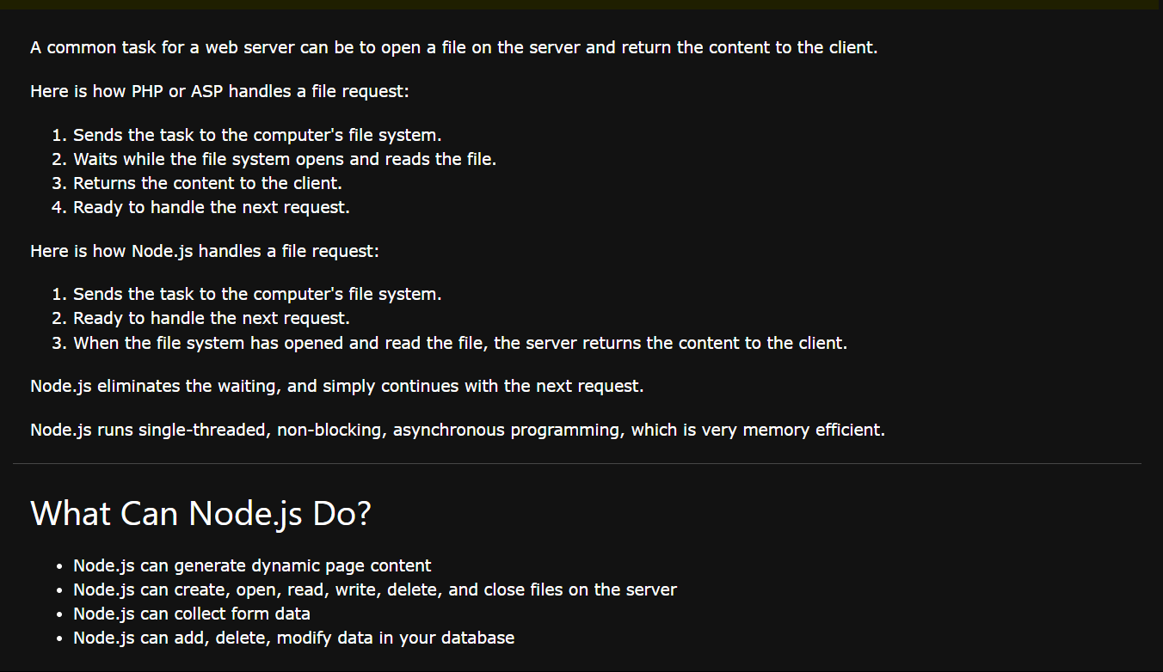

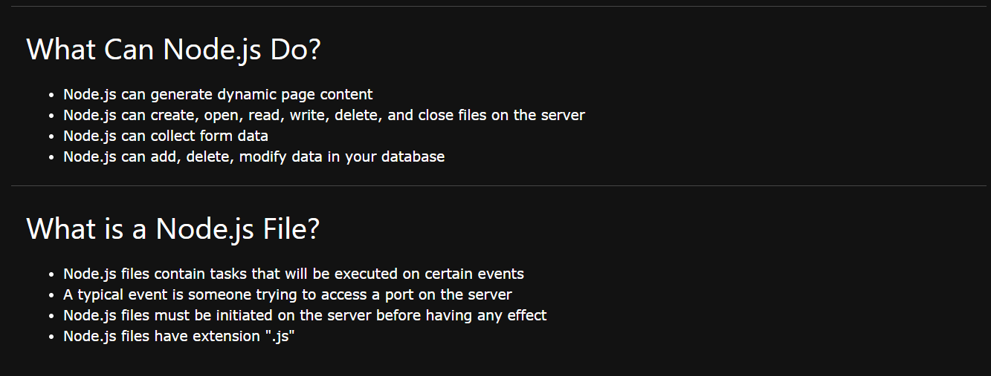

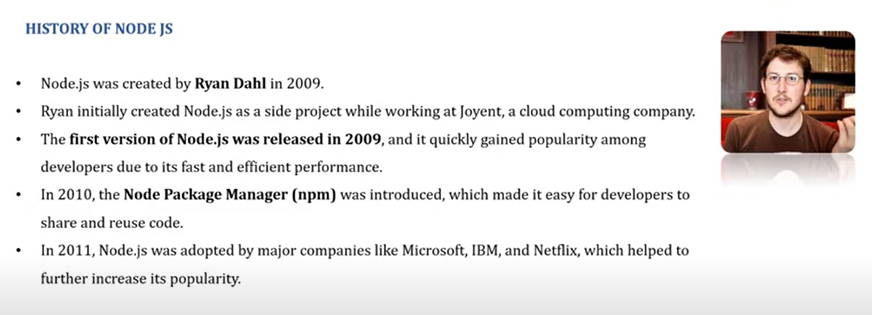

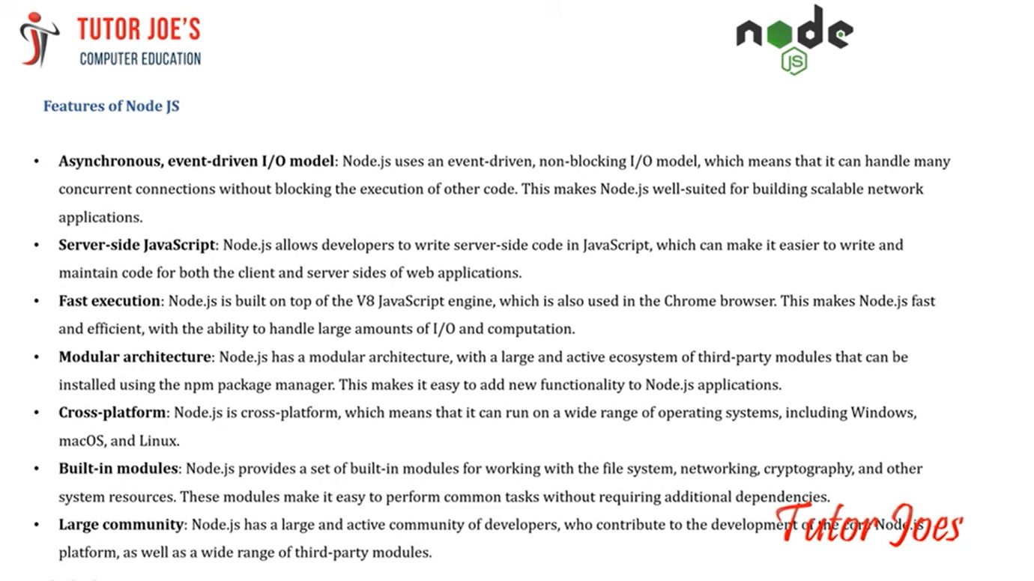

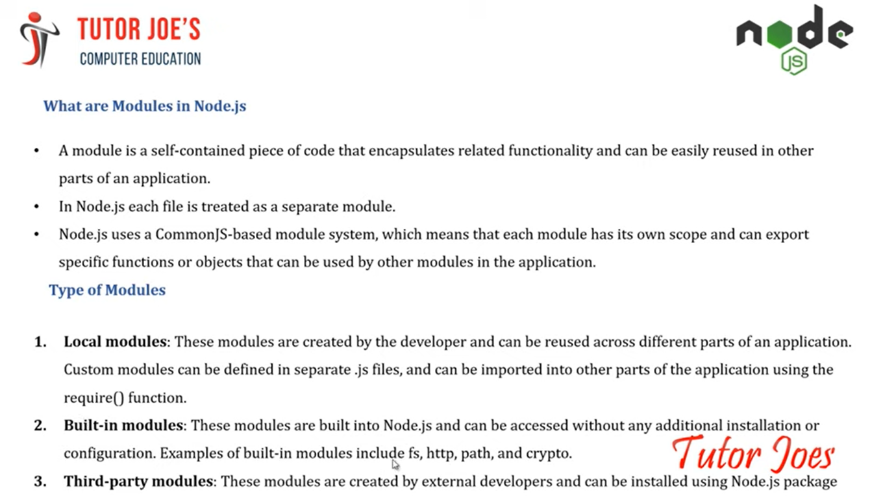

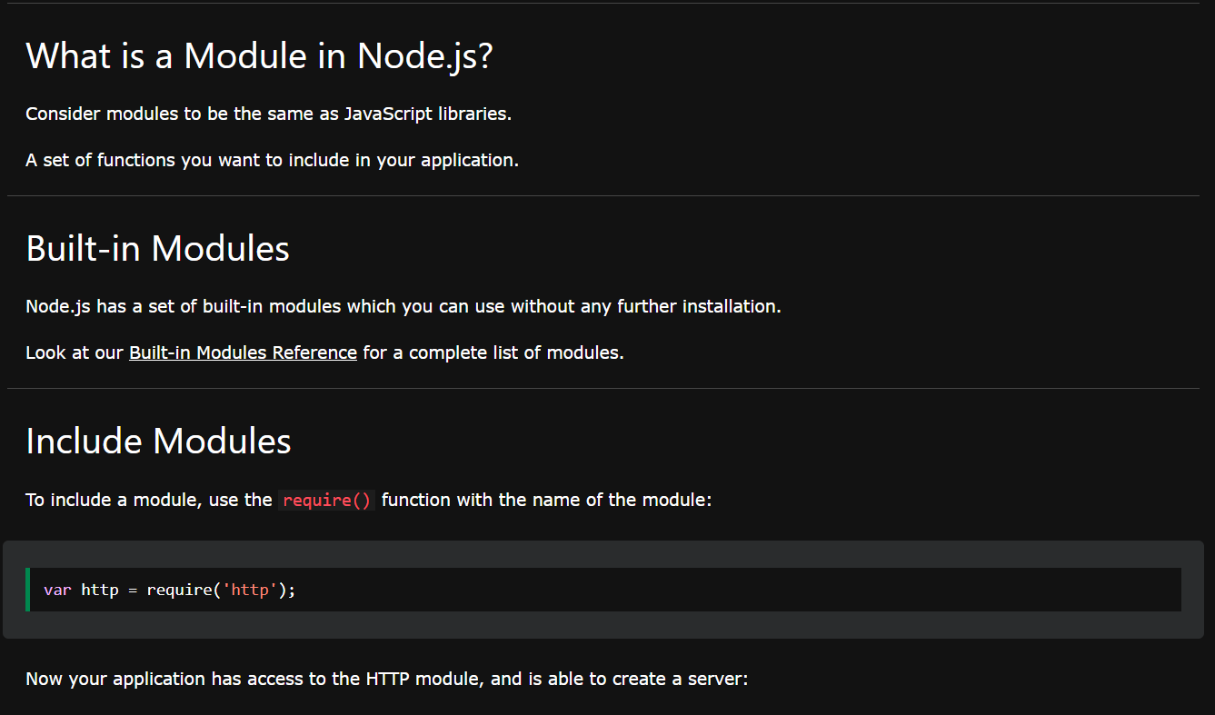

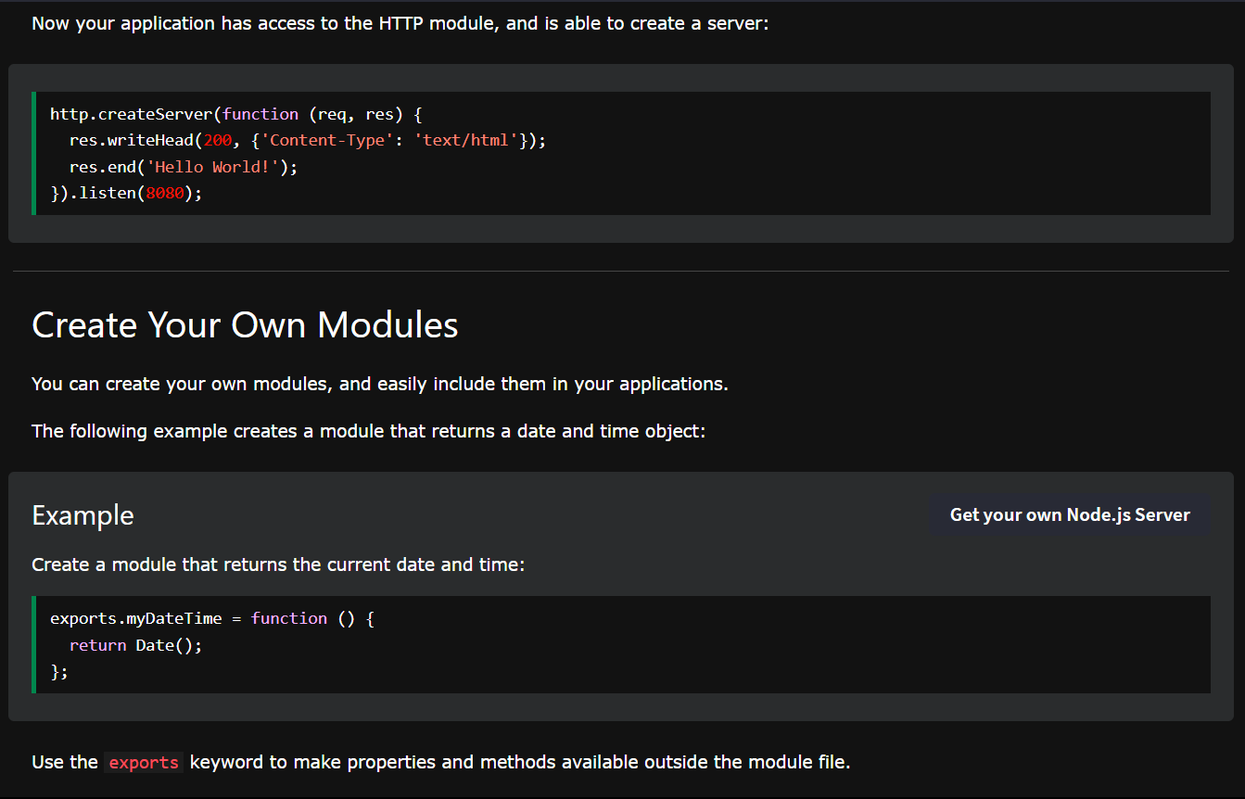

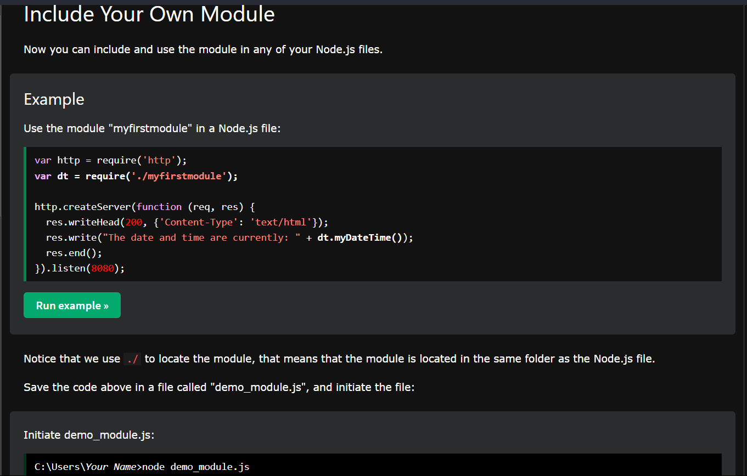

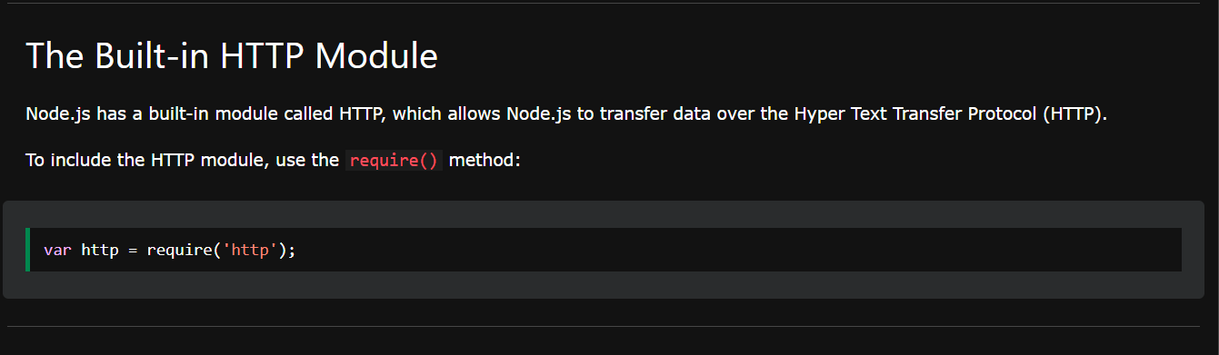

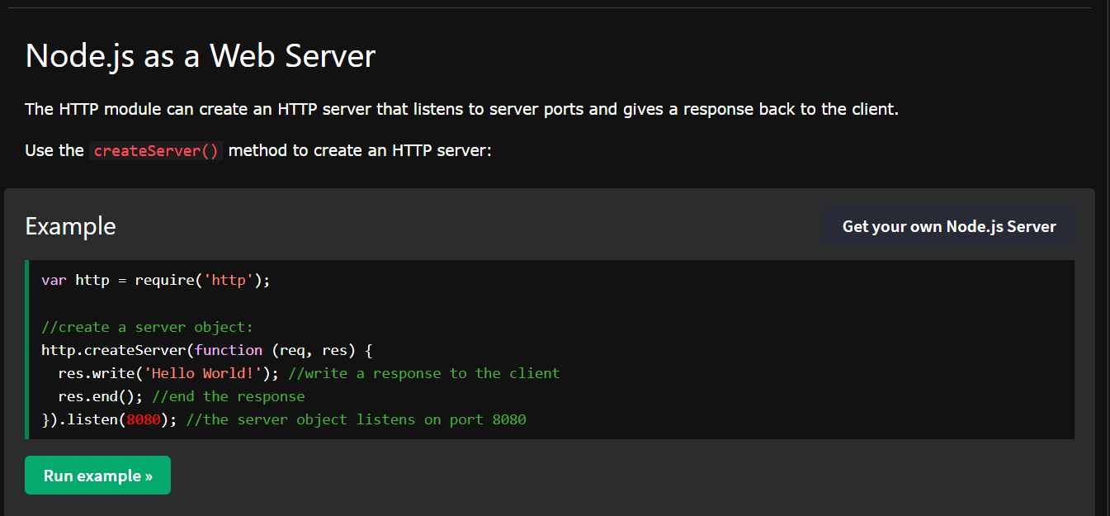

**Node js File System Module:** <https://www.w3schools.com/nodejs/nodejs_filesystem.asp>

**Node.js URL Module:** <https://www.w3schools.com/nodejs/nodejs_url.asp>

**Node.js NPM:**

<https://www.w3schools.com/nodejs/nodejs_npm.asp>

**Node.js Events**: <https://www.w3schools.com/nodejs/nodejs_events.asp>

**Built-in-Modules:** <https://www.w3schools.com/nodejs/ref_modules.asp>

**Node.js Upload Files**

<https://www.w3schools.com/nodejs/nodejs_uploadfiles.asp>

**Node.js Send an** [**Email** :https://www.w3schools.com/nodejs/nodejs_email.asp](https://www.w3schools.com/nodejs/nodejs_email.asp)